**DEPARMENT OF ELECTRONICS AND COMMUNICATION**

The faculty of the department of Electronics and Communication is striving hard to update themselves with the on technology by completing the certification courses by COURSERA



**Niharika**

Completed three courses successfully with certifications.

**1. Electric Power Systems**

It introduces the electric power system, from generation of the electricity all the way to the wall plug. It verses about the segments of the system, and common components like power cables and transformers. It explores various facets of the power sector to achieve a self-established, energy-related professional goal.

**2. Understanding Research Methods**

It outlines the fundamentals of doing research like Importance of Literature Review, How to formulate a research problem, how to be satisfied and content with your own research. The course is especially for those who require an understanding of research approaches and skills, and importantly an ability to deploy them in their research studies or professional lives.

**3. Linear Analysis-DC Circuits**

This course explains how to analyze circuits that have direct current (DC) current or voltage sources. A DC source is one that is constant. Circuits with resistors, capacitors, and inductors are covered, both analytically and experimentally.

**Nitika**



Completed certified skill development program.

* **Online Certified Skill Development Program on Design, Implementation and Verification in VLSI**

This program gives participants an insight into the processes involved in taking a digital design from concept to realization using an FPGA. The instructor-led program was a blend of lectures and demonstrations to enhance learning of the Vivado design flow. It also gives an introduction to the verification of the design.

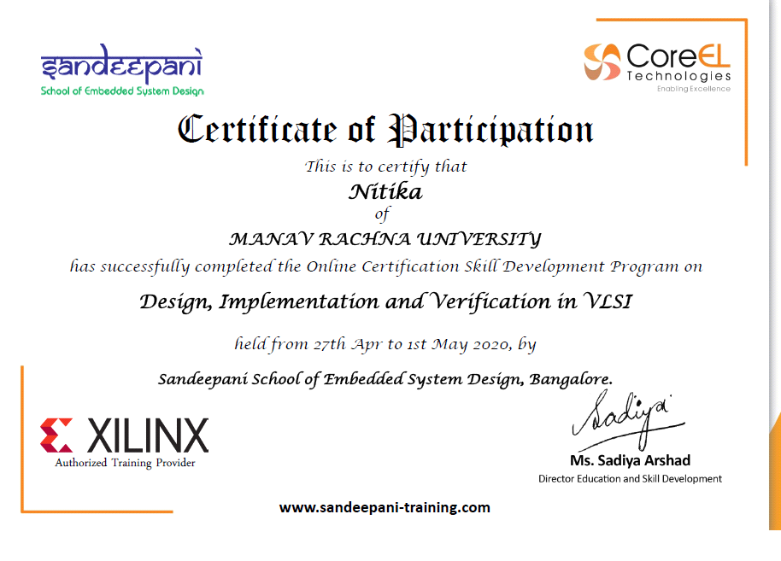

**Yogita**



Completed two certification courses

**1. Understanding Research Methods**

It outlines the fundamentals of doing research like Importance of Literature Review, How to formulate a research problem, how to be satisfied and content with your own research. The course is especially for those who require an understanding of research approaches and skills, and importantly an ability to deploy them in their research studies or professional lives.

**2. Linear Analysis-DC Circuits**

This course explains how to analyze circuits that have direct current (DC) current or voltage sources. A DC source is one that is constant. Circuits with resistors, capacitors, and inductors are covered, both analytically and experimentally.