Annexure-5
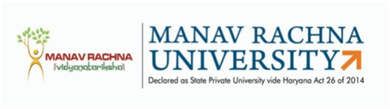
MANAV RACHNA UNIVERSITY
Sector-43, Aravali Hills, Faridabad

Report of SRC

Mr/Ms. …………………………… Registration No………………………….. presented Research Progress before Student Research Committee (SRC) on Broad Area……………………………………………………………………..title of Proposed Research Work is …………….....................................................................................................................on dated……………………… The scholar is working under the supervision of Dr. ………………………. (Supervisor) and Dr. ………………… (Co-Supervisor -if any).
Comments/Suggestions for research work done by the scholar in …………………..semester:
………………………………………………………………………………………………………………………………………………………………………………………………………………………………………………………………………………………………………………………
The recommendations of SRC on Short Synopsis/Long Synopsis/Draft Thesis is

- Approved with No changes
- Approved with Minor changes
- Approved with Major changes
- Not Approved
- Not Applicable

SRC Chairperson

SRC Member(s)

Name, Designation & Signature

Note: Send a copy of duly filled report to:
a) SRC Members
b) DRC Chairperson
c) Ph.D Scholar
d) Ph.D Office

